**Assignment No:-69**

Name:-Suryawanshi Sangramsingh Sambhaji

Batch: - Delta - DCA (Java) 2024 Date:-1/9/2024

1. Write a Java program to filter out all even numbers from a list using the Stream API.

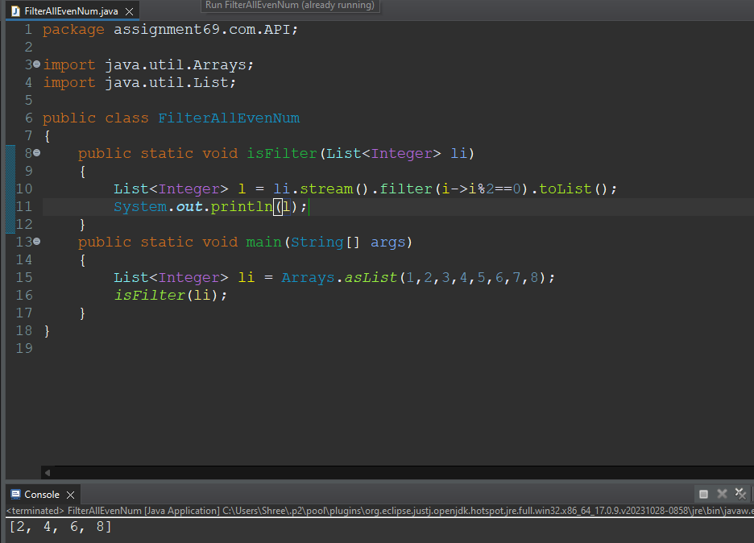

2. Given a list of strings, write a Java program to convert all strings to uppercase using the Stream API.

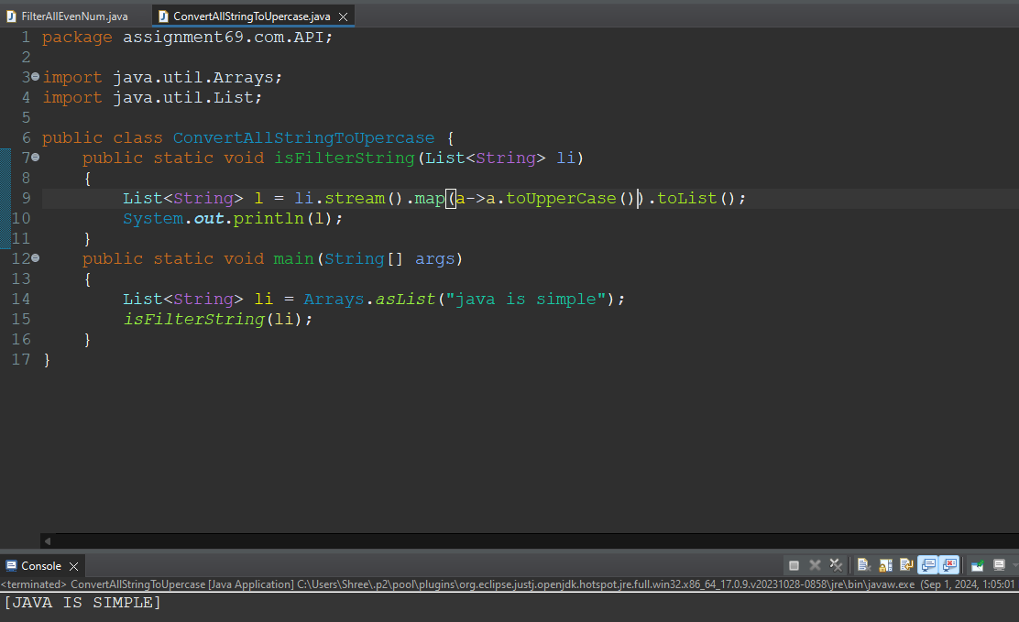

3. Write a Java program to find the sum of all integers in a list using the Stream API.

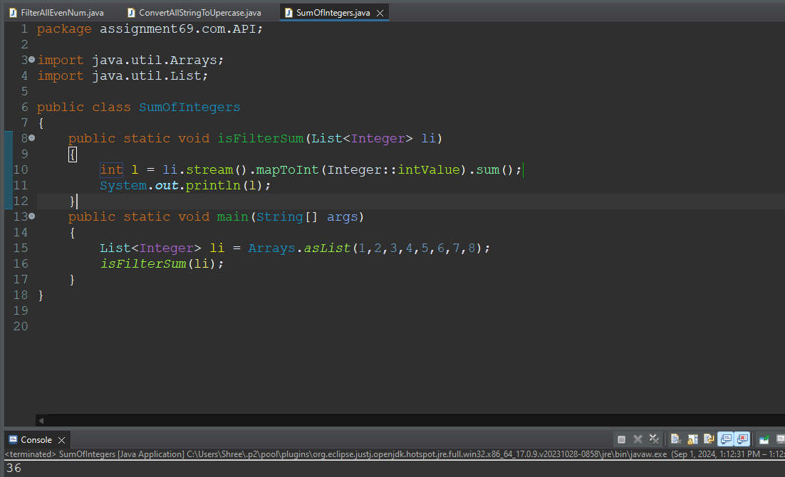

4. Given a list of integers, write a Java program to find the maximum value using the Stream API.

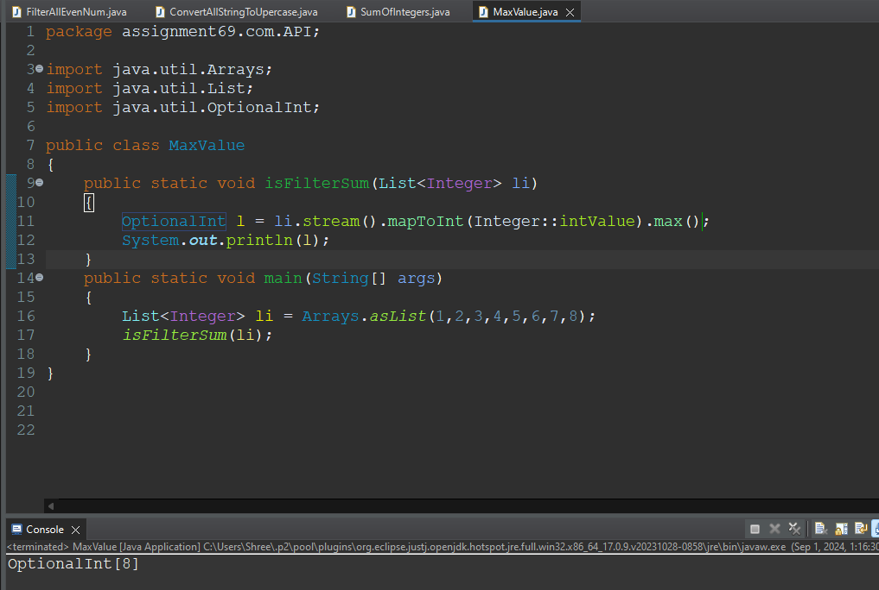

5. Write a Java program to count the number of strings with length greater than 5 in a list using the Stream API.

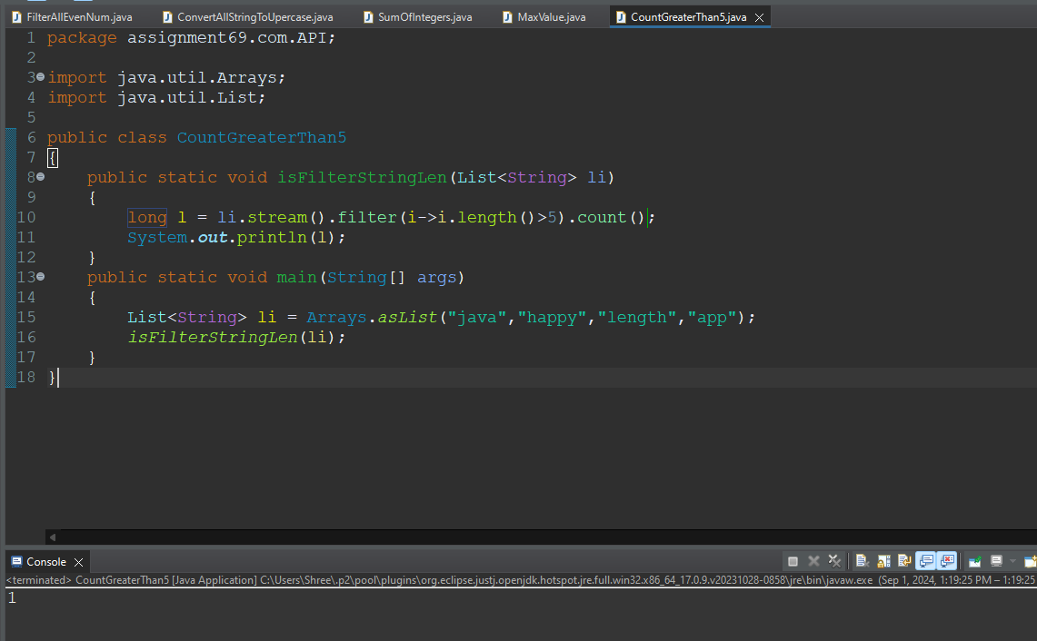

6. Given a list of integers, write a Java program to sort them in ascending order using the Stream API.

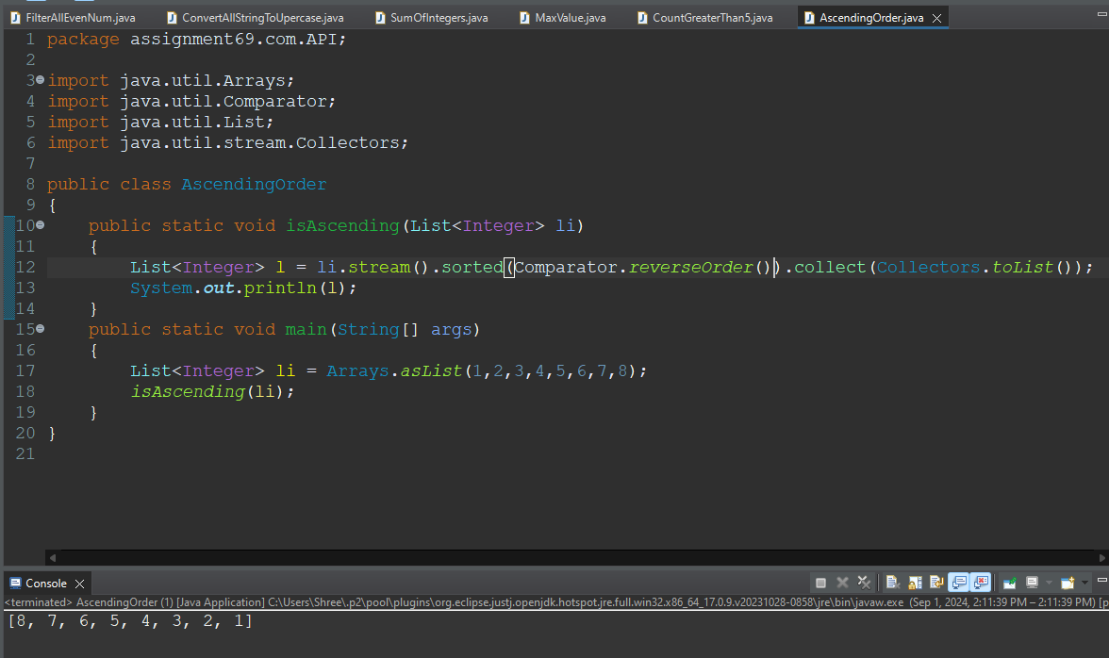

7. Write a Java program to create a list of squares of all integers from a given list using the Stream API.

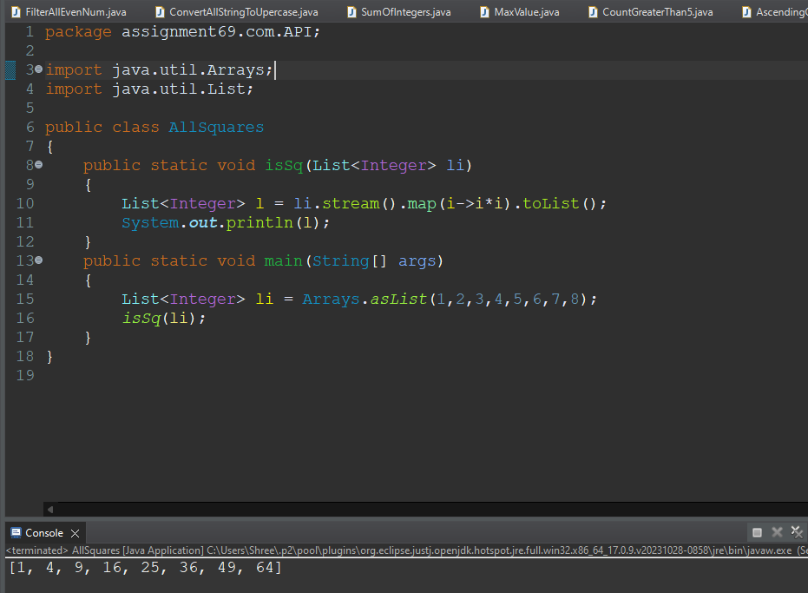

8. Given a list of strings, write a Java program to filter out strings that start with a specific letter using the Stream API.

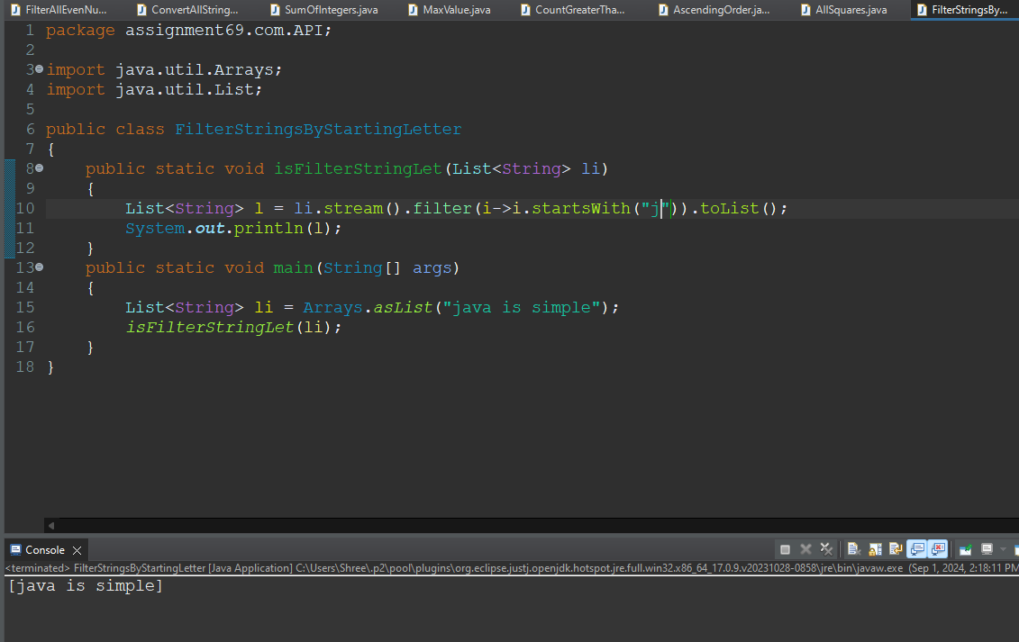

9. Write a Java program to concatenate all strings in a list using the Stream API.

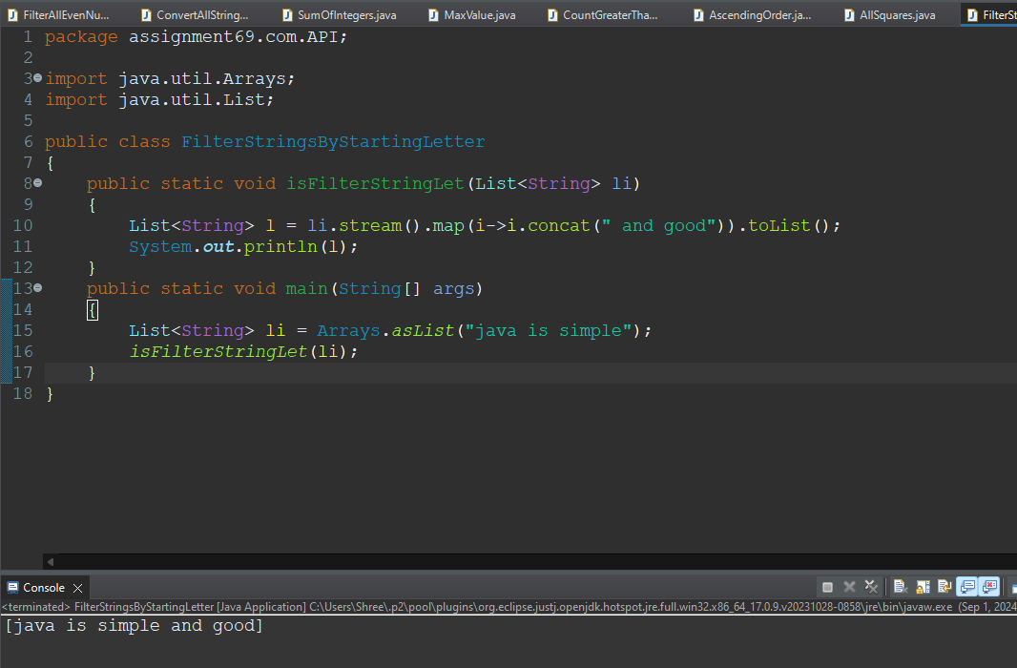

10. Given a list of integers, write a Java program to find the average of the numbers using the Stream API.

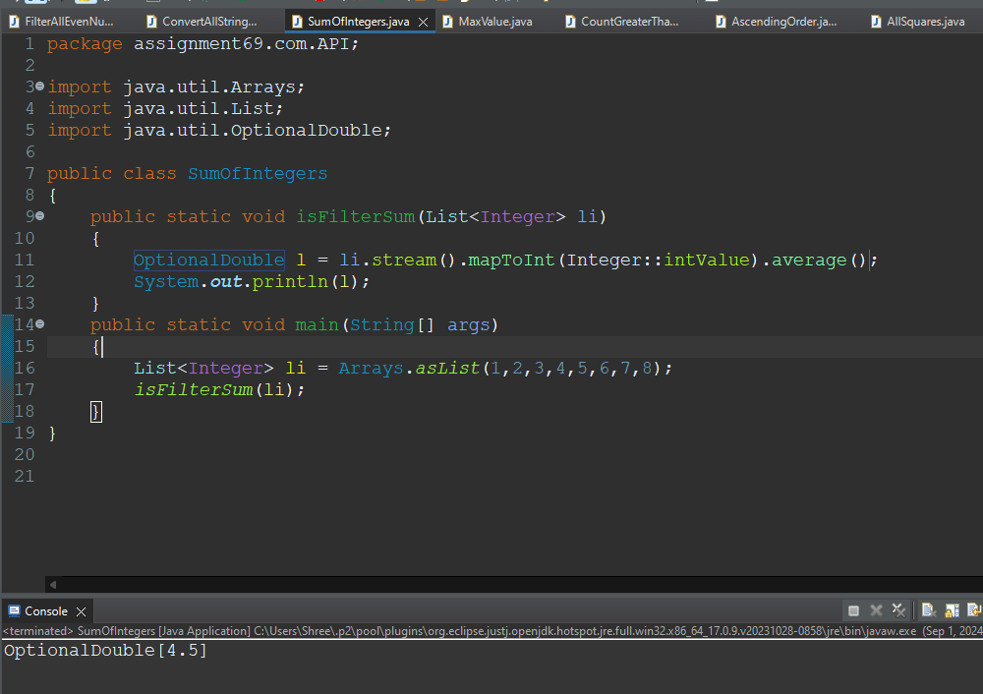

11. Write a Java program to remove duplicates from a list of integers using the Stream API.

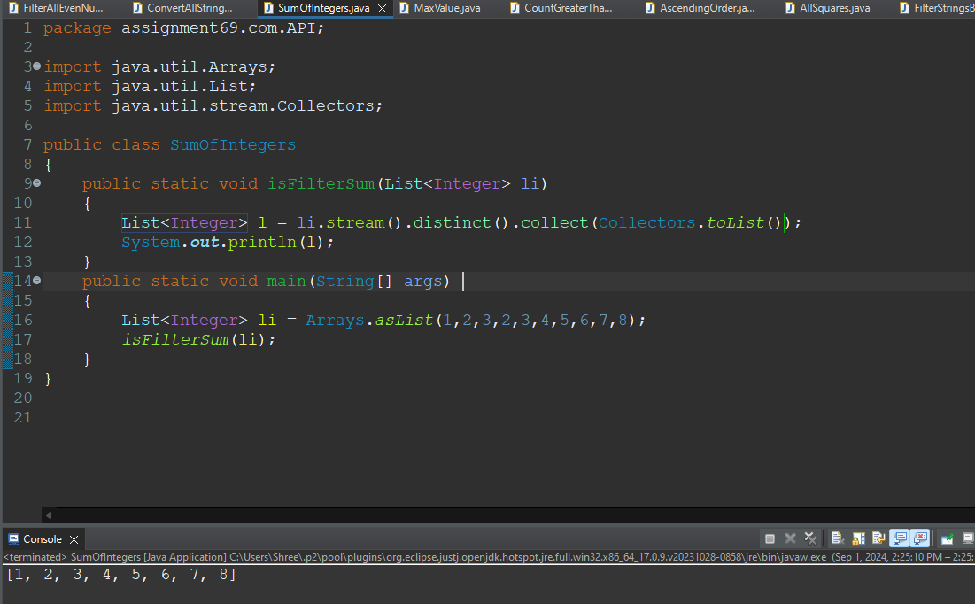

12. Given a list of objects with a field age, write a Java program to filter out objects with age greater than 30 using the Stream API.

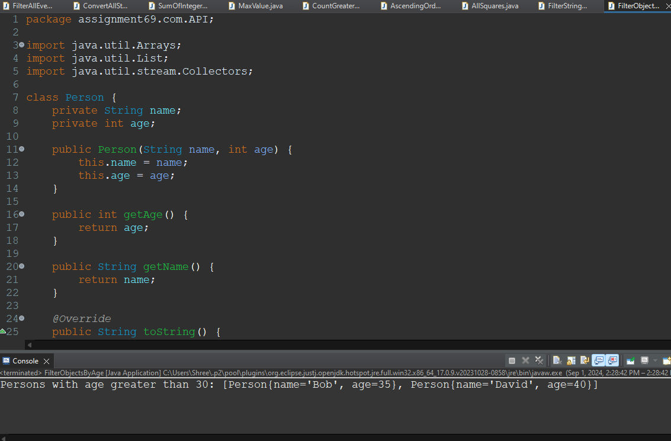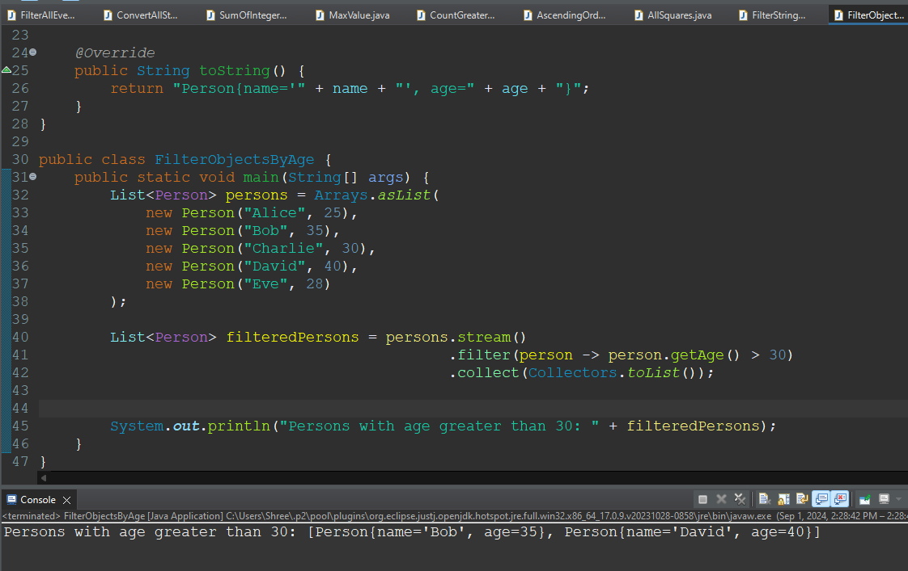

13. Write a Java program to group a list of strings by their length using the Stream API.

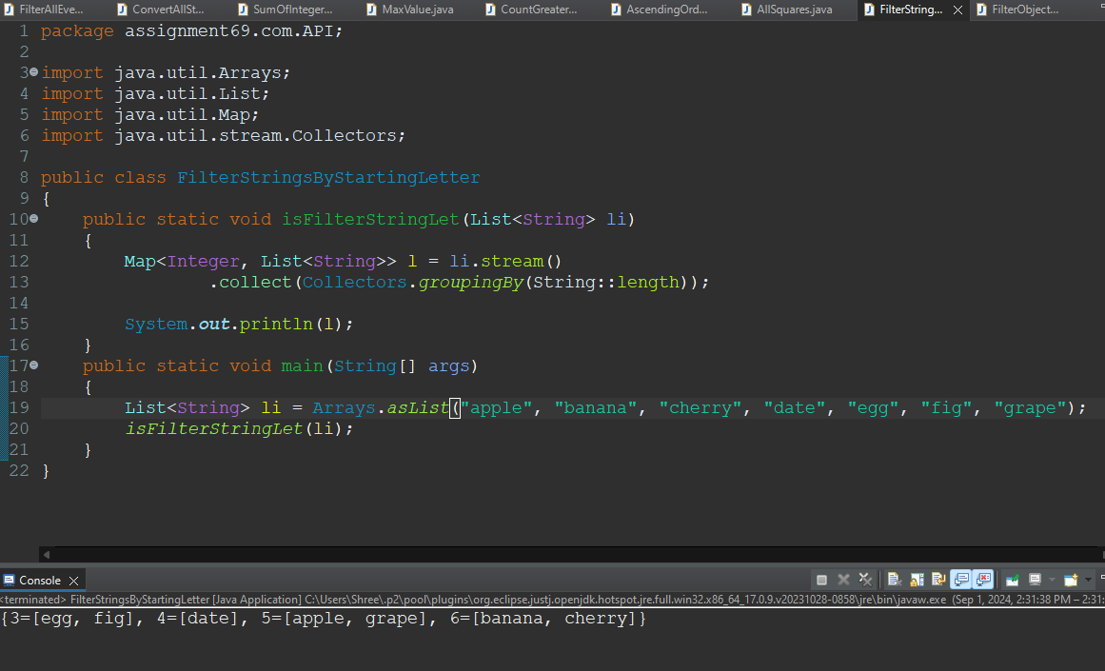

14. Given a list of integers, write a Java program to find the second highest number using the Stream API.

